**Invoice**

# 3

Green Spoon Vegetarian Kitchen

4321 Maplewood Ave, Nashville, TN, 10105,

[greenspoon@example.com](mailto:greenspoon@example.com)

**Billed To**

Maria Sullivan The Palm Tree Nursery 987 6th Ave Santa Fe, NM 11121 201-555-0122

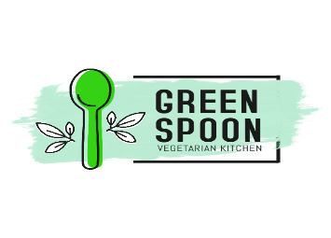

**Invoice Date:** 01/7/2024

**Due Date:** 31/7/2024

**Shipped To**

Maria Sullivan The Palm Tree Nursery 987 6th Ave Santa Fe, NM 11121 201-555-0122

| **Item** | **Quantity** | **Rate** | **Tax Rate** | **Amount** |
| --- | --- | --- | --- | --- |
| Areca palm | 20 | 2.5 | 0% | 50 |
| Majesty palm | 35 | 3 | 0% | 105 |
| Bismarck palm | 15 | 2.5 | 0% | 37.5 |

### Terms and Conditions:

Make all checks payable to Green Spoon Vegetarian Kitchen

### Notes: Thank you for your business!

|  |  |
| --- | --- |
| **Subtotal** | **$ 192.5** |
| **Discount** | **$ 2.5** |
| **Shipping Fee** | **$ 10** |
| **Total** | **$ 200** |
| **Amount Paid** | **$ 50** |
| **Balance Due** | **$ 150** |